

***Government College of Engineering and Ceramic Technology***

**Statistical Analysis of ECG Signal for Myocardial Ischemia**

*Name:*

*Roll no.:*

*Registration No.:*

*Department:*

*Year:*

**ABSTRACT**

Electrocardiogram (ECG), a noninvasive technique is use as a primary diagnostic tool for cardiovascular diseases. A cleaned ECG signal provides necessary information about the electrophysiology of the heart diseases and ischemic changes that may occur. It provides valuable information about the functional aspects of the heart and cardiovascular system. The objective of the project is to automatic detection of cardiac diseases from ECG signal. The aim of this work is to detect automatically the R peaks, the T and P wave maxima, separately. After having represented the ECG equivalent in time frequency domain, we detect the slope of the QRS complex and ST elevation. Then we construct an one dimensional convolutional neural network to detect any abnormality in the ECG waveforms. After training and testing our model, it will be able to detect Myocardial Ischemia. The method is tested on inputs taken from European ST-T database from Physiobank database.

**MAIN REPORT**

**Introduction**

Myocardial ischemia occurs because of insufficient oxygen supply to the heart, leading to ischemic heart disease (IHD). It is the leading cause of death worldwide, responsible for more than 8 million deaths globally every year (World Health Organization, 2016). If untreated, ischemia can lead to a myocardial infarction (MI), commonly known as a heart attack. MI causes cell death and can lead to permanent damage to the heart muscle if not treated immediately. In many cases early signs of ischemia are overlooked or ignored by the patient. Timely detection and treatment of IHD can stop progression towards MI and save many lives and prevent permanent damage to heart muscle. Thus, the aim is to develop an algorithm to detect ischemic events in ambulatory ECG signals. This can be used for continuous monitoring of a suspected ischemic patient and provide early detection of myocardial ischemia.

* **Human Heart:**

The human heart is an organ that pumps blood throughout the body via the circulatory system, supplying oxygen and nutrients to the tissues and removing carbon dioxide and other wastes.

Blood delivers oxygen and nutrients to every cell and removes the carbon dioxide and other waste products made by those cells.

Blood is carried from the heart to the rest of the body through a complex network of arteries, arterioles and capillaries. Blood is returned to the heart through venules and veins.

* **The Heart Anatomy:**

The heart is made up of four chambers: two upper chambers known as the left atrium and right atrium and two lower chambers called the left and right ventricles.

It is also made up of four valves: the tricuspid, pulmonary, mitral and aortic valves.

* The right atrium receives non-oxygenated blood from the body’s largest veins — superior vena cava and inferior vena cava — and pumps it through the tricuspid valve to the right ventricle.
* The right ventricle pumps the blood through the pulmonary valve to the lungs, where it becomes oxygenated.
* The left atrium receives oxygenated blood from the lungs and pumps it through the mitral valve to the left ventricle.
* The left ventricle pumps oxygen-rich blood through the aortic valve to the aorta and the rest of the body.
* The coronary arteries run along the surface of the heart and provide oxygen-rich blood to the heart muscle.

A web of nerve tissue also runs through the heart, conducting the complex signals that govern contraction and relaxation. A sac known as the pericardium surrounds the heart.

The outer layer of the pericardium surrounds the roots of the heart’s major blood vessels, and the inner layer is attached to the heart muscle.

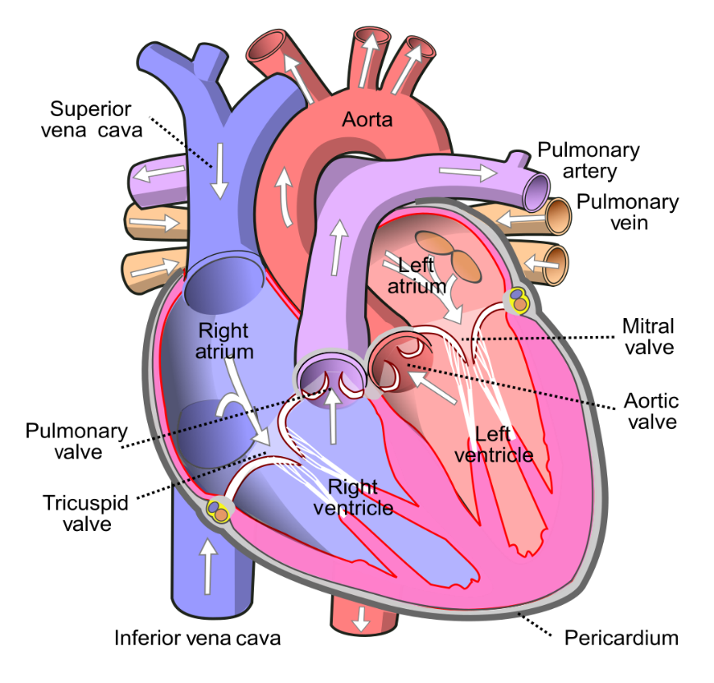

Anatomy of Human heart

* **Electrocardiogram (ECG):**

It’s a non-invasive method of measuring the heart’s electrical activity during the cardiac cycle.

**Electrocardiography** is the process of producing an **electrocardiogram** (**ECG** or **EKG**). It is a graph of [voltage](https://en.wikipedia.org/wiki/Voltage) versus time of the electrical activity of the [heart](https://en.wikipedia.org/wiki/Heart" \o "Heart) using [electrodes](https://en.wikipedia.org/wiki/Electrode" \o "Electrode) placed on the skin. These electrodes detect the small electrical changes that are a consequence of cardiac muscle [depolarization](https://en.wikipedia.org/wiki/Depolarization" \o "Depolarization) followed by [repolarization](https://en.wikipedia.org/wiki/Repolarization" \o "Repolarization) during each cardiac cycle (heartbeat). Changes in the normal ECG pattern occur in numerous cardiac abnormalities, including cardiac rhythm disturbances (such as [atrial fibrillation](https://en.wikipedia.org/wiki/Atrial_fibrillation" \o "Atrial fibrillation) and [ventricular tachycardia](https://en.wikipedia.org/wiki/Ventricular_tachycardia" \o "Ventricular tachycardia)), inadequate coronary artery blood flow (such as [myocardial ischemia](https://en.wikipedia.org/wiki/Myocardial_ischemia" \o "Myocardial ischemia) and [myocardial infarction](https://en.wikipedia.org/wiki/Myocardial_infarction" \o "Myocardial infarction)), and electrolyte disturbances (such as [hypokalaemia](https://en.wikipedia.org/wiki/Hypokalemia" \o "Hypokalemia) and hyperkalaemia).

* **What does an ECG measure?**

A single round of the cardiac cycle shows up in 3 main “waves” on an ECG—the P wave, the QRS complex, and the T wave. These waves reflect the activities of the heart’s electrical conduction system, which is composed of specialized muscle fibres.

***P wave:***A heartbeat starts with the generation of an electrical signal at the sinoatrial node (SA node)—the heart’s natural pacemaker—and that signal subsequently passes to the atrioventricular node (AV node). On an ECG, this is what the P wave, that first little blip, represents. The electrical signal that begins at the SA node and travels to the AV node stimulates the atria of the heart to contract, pushing blood into the ventricles.

***PR Interval:***The PR interval is the time between the start of the P wave and the start (the first deflection) of the QRS complex.

***QRS wave complex***The big spike in the middle of the ECG is the QRS complex, which reflects the electrical signals leading to ventricular contraction. It’s made up of multiple waves, but they’re usually grouped together for analysis.

Once the electrical signal reaches the AV node, it passes on to the atrioventricular bundle (bundle of His), and then it travels down the bundle fibers to the Purkinje fibers. This stimulates the contraction of the ventricles, pushing blood out of the heart through the pulmonary artery and aorta.

***ST Interval***:  
The ST interval, or ST segment, is the time between the end of the QRS complex and the start of the T wave. This means it represents “[the period of zero potential between ventricular depolarization and repolarization](https://www.ncbi.nlm.nih.gov/books/NBK2214/)”.

***T wave:***The T wave represents the heart’s electrical activity returning to baseline—ventricular repolarization. (Atrial repolarization occurs during the QRS complex, so it isn’t clearly visible on the ECG readout.) After ventricular repolarization, the muscles of the ventricles relax.

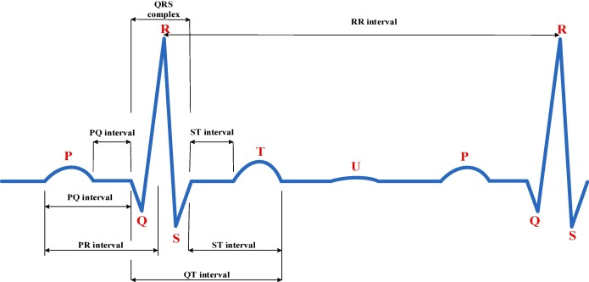

A Normal ECG Signal

* 12 Lead ECG:

The standard ECG has 12 leads. Six of the leads are considered “limb leads” because they are placed on the arms and/or legs of the individual. The other six leads are considered “precordial leads” because they are placed on the torso (precordium).

The six limb leads are called lead I, II, III, aVL, aVR and aVF. The letter “a” stands for “augmented,” as these leads are calculated as a combination of leads I, II and III.

The six precordial leads are called leads V1, V2, V3, V4, V5 and V6.

* **In Myocardial Infraction changes in ECG are:**
* ST segment elevation
* T wave inversion
* Appearance of wide deep Q waves.

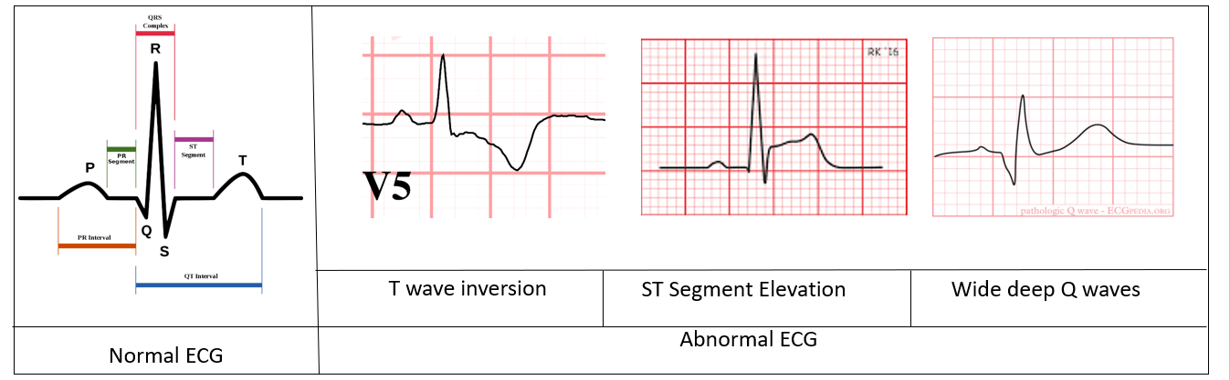

**Objective:** The Objective of this project is to automate the detection of cardiac disease- Myocardial Ischemia from ECG Signal. The aim of this project is to detect R peak, the slope of QRS Complex and T wave. After obtaining the following values we have created a Convolutional Neural Network (CNN) based Deep Learning (DL) model that detects whether a patient, whose ECG signal is fed into the model is suffering from myocardial disease or not.

**Scope:** The accuracy can be improved when the threshold is selected from a larger dataset. However one thing is observed that this method can provide a patient specific monitoring system for ischemia. If medical experts’ opinion is included in the phase of manually training the model, then detection accuracy can be improved also with their suggestions. Using this method, many other heart diseases like Hyperkalemia,Cardiac Hypertrophy, Cardiac infraction (from QRS complex abnormality) and Ventricular Hypertrophy, pre excitation syndrome , Digitalis effect (from T wave abnormalities ) etc can also be detected. This project model can be considered as a demo for such personal healthcare and disease detecting algorithm which can be equipped with better techniques in future.

**Limitation:** This model needs extensive dataset for training and experts’ suggestion for improvement. As a personal healthcare device, this can be difficult for a common person. It uses enough system resources.

**Features:** The main aim of our project is to develop a code to detect specifically whether a person

is having myocardial ischemia or not with the help of required no. of ECG signal dataset without

having to go to the clinic.

Any person anywhere in the world can use this whenever needed with a code executable machine

in hand (Laptop,desktop,ph..etc).So, anyone can use it easily without much knowledge.

A small or a minor change in the dataset won’t largely affect the code performance as it is deeply

trained by the use of convolutional neural network.

It is platform independent that it can run on any system and with that we need python 3.6.5

software only.

**Platform:** As we know Python is almost platform independent, so any platform or system able to run Python can run the software.

**Software and Hardware requirement**

Any Operating system except linux with upgraded version of python 3.6.5 software.

Tensorflow -gpu -: 1.2.3-It is an open source artificial intelligence library, using data flow graphs to build models. It allows developers to create large-scale neural networks with many layers. TensorFlow is mainly used for: Classification, Perception, Understanding, Discovering, Prediction and Creation.

Keras 2.3.1-: Keras is the python Deep learning library. It is an open-source software library that provides a Python interface for artificial neural networks. Keras acts as an interface for the TensorFlow library.

Wfdb 3.0.1-: The native Python waveform-database (WFDB) package. A library of tools for reading, writing, and processing WFDB signals and annotations.

Data requirements: We used the European-st-t database which was intended to be used for evaluation of algorithms for analysis of ST and T- wave changes. This database consists of 90 annotated excerpts of ambulatory ECG recordings from 79 subjects.

And we as a group of 4 have used 4 databases (e0103,10104,e0105 and e0108) respectively i.e. the ECG record of Four patient as our training and test dataset for the execution of the code.

In each data set we run a code where the dataset is divided into segments having 240 data point each(a typical heart rate has 70 to 75 beats per minute, i.e. each cardiac cycle takes about 0.8 seconds to complete the cycle).

**SOURCE CODE OF THE PROJECT**

We have created the script gen_manual_verdict.py to process european st-t dataset to generate training data for our CNN model. Next we train our model using train_model.ipynb. The script also generates .hdf5 file so that our model can be used everywhere. Next check_individual_inputs.ipynb is used for checking individual records. We also recorded the angles for the R peaks in the ECG signals.

At first we plotted the ECG signals to see their pattern.

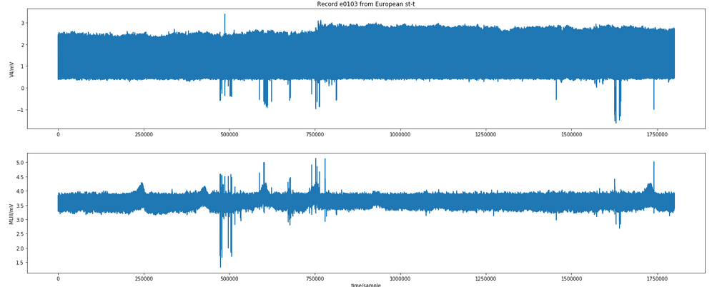

Next we used XQRS detection to detect the R peaks in the ECG.

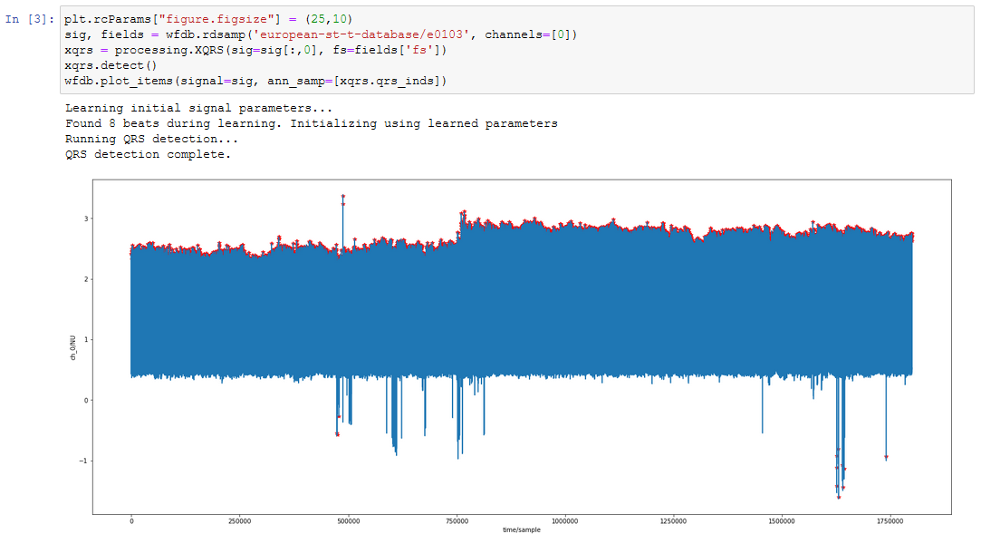

Next we sliced the first 250 points from the ECG recording and tried to locate the Q and S points from the change in slope the wave.

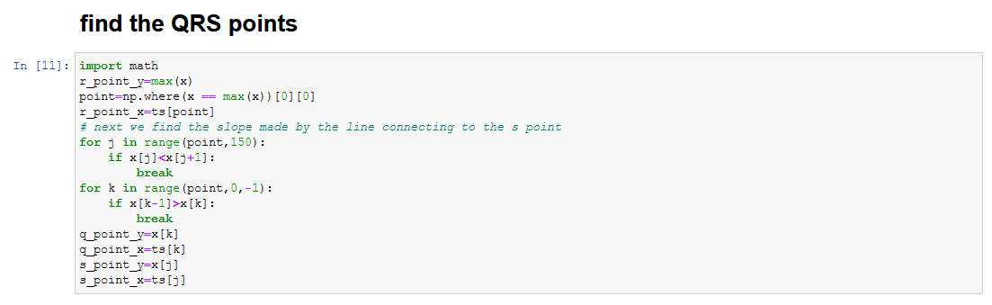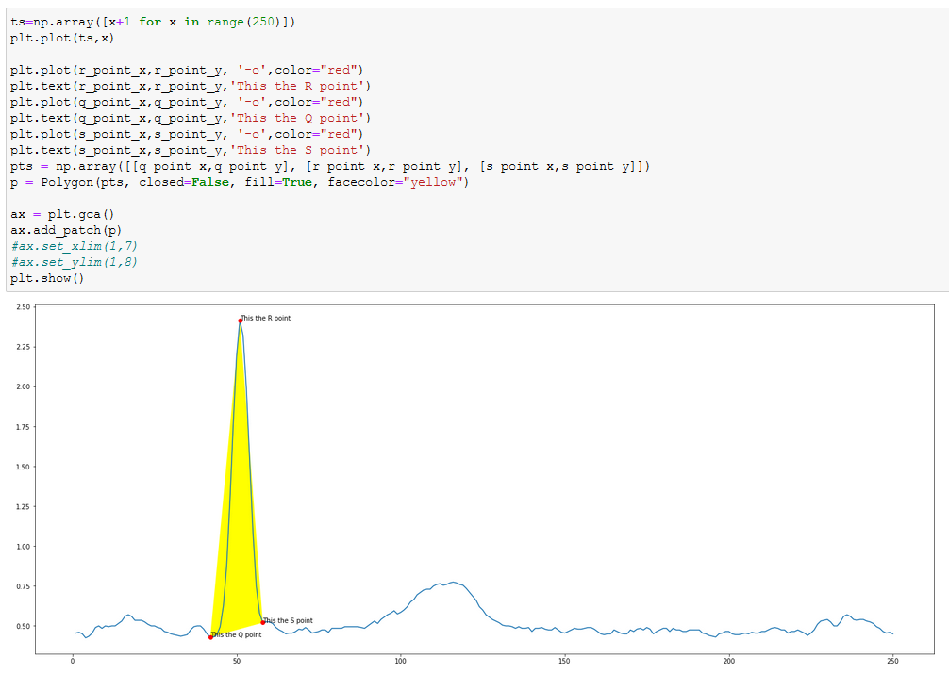

We checked the duration of an average heartbeat which is 0.8 and then we calculated the number of samples that would make a heartbeat in ECG recording of st-t dataset whivh turned out to be 200 samples for 250 Hz recording rate. We took 40 samples as buffer and then sliced the dataset for every 240 units of data. And labeled this slices for myocardial ischaemia. For this we used a script which sliced and showed us ECG plot and we entered the label for the recording.



Next we processed our data to be fed into our CNN model for training.

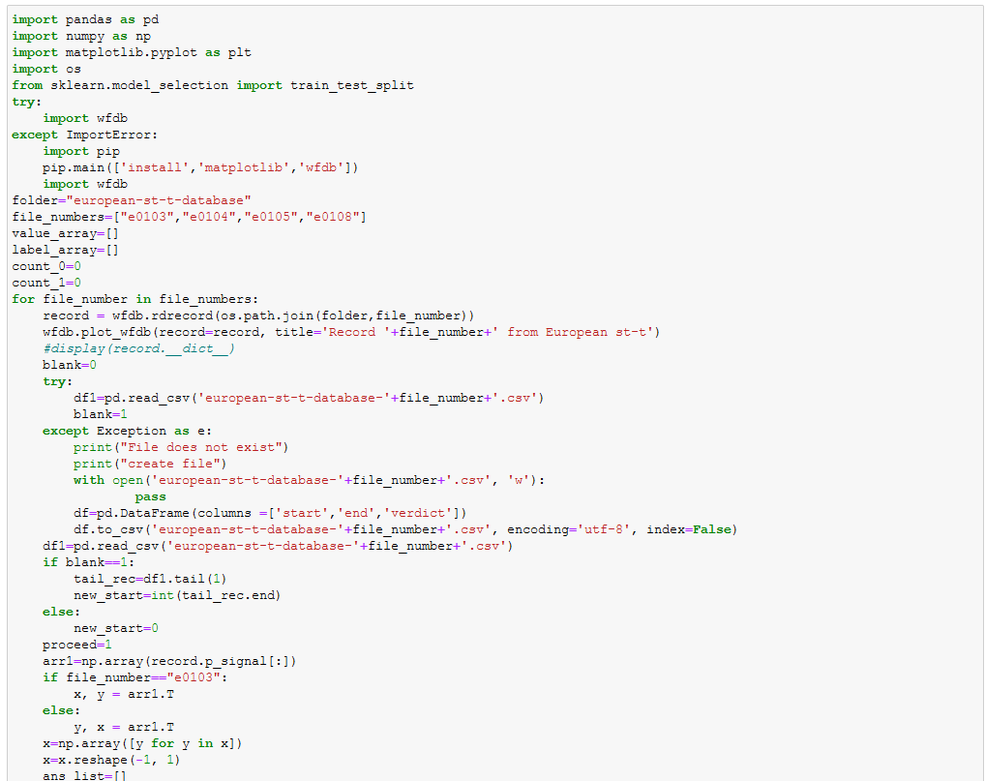

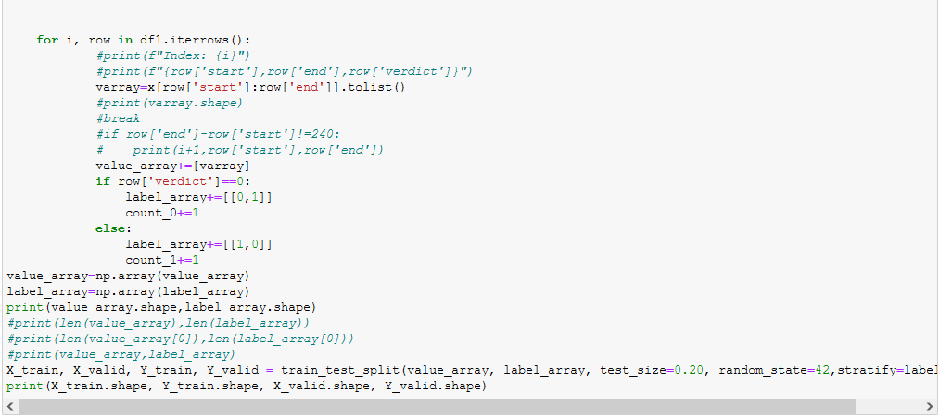

So we have our train and test dataset now.

Creating our CNN model.

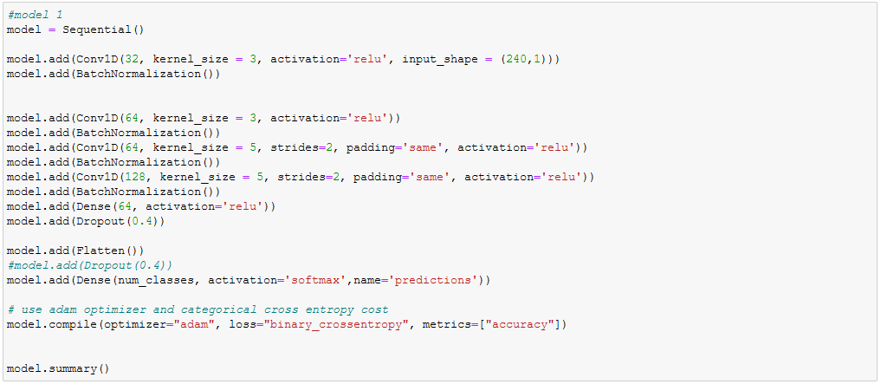

Training our model using a GTX 1660 .

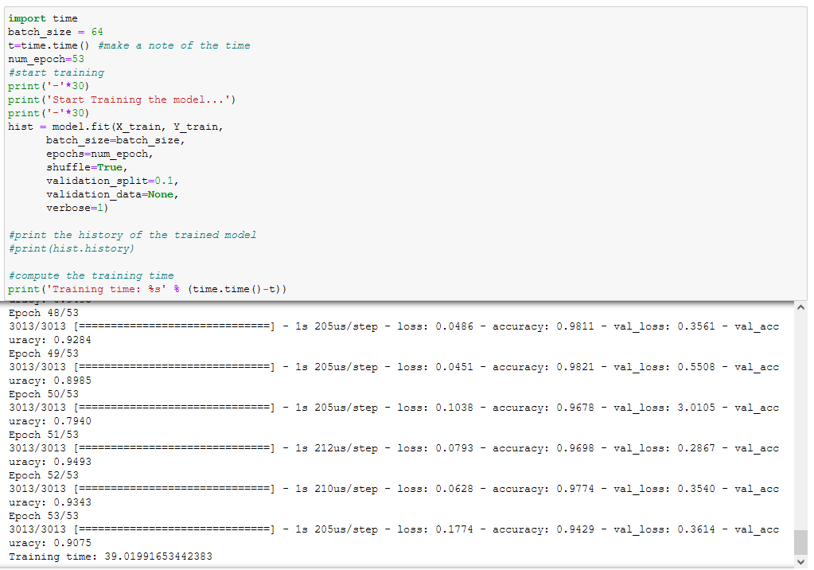

Plotting the graphs for training accuracy and loss.

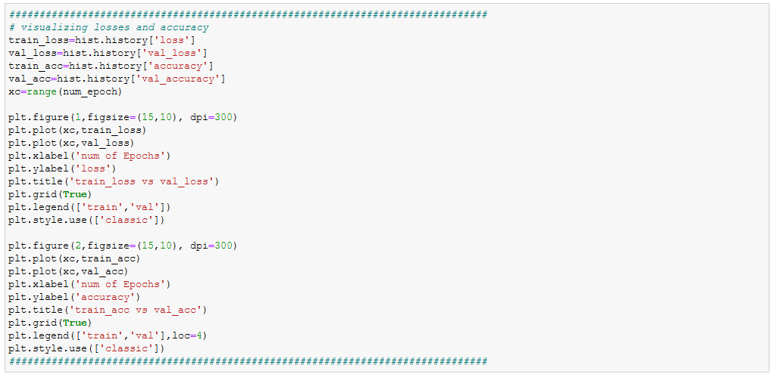

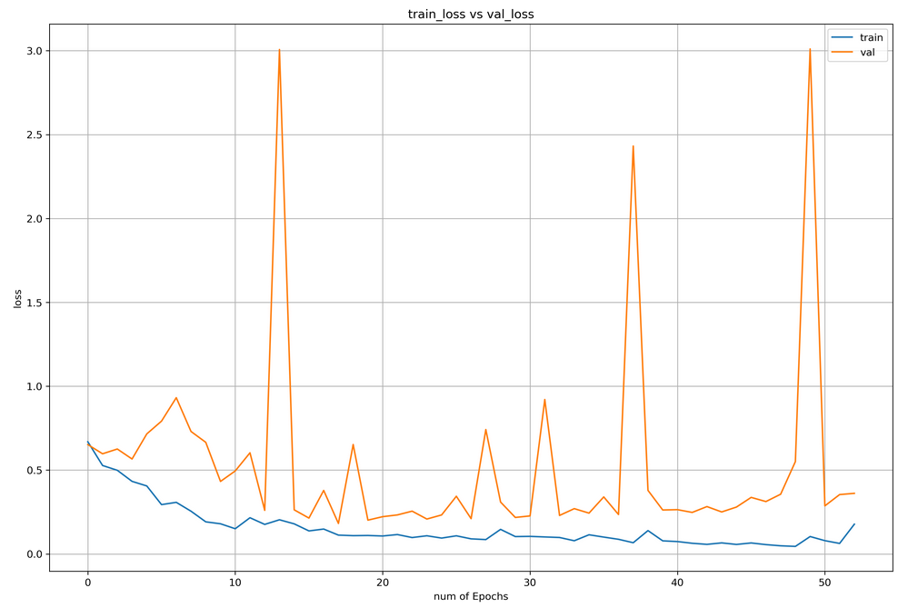

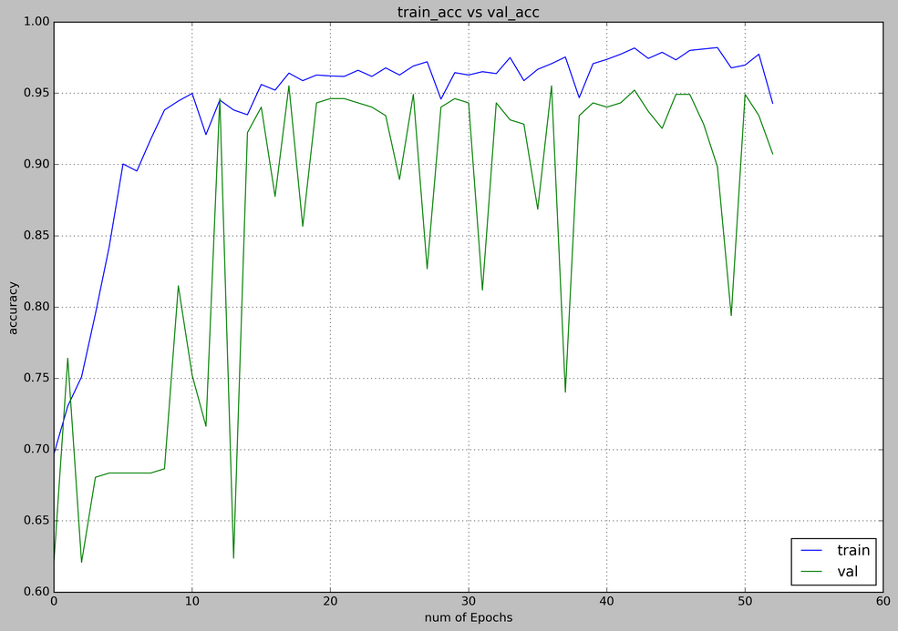

Saving our model structure and its weights for the Neural Network.

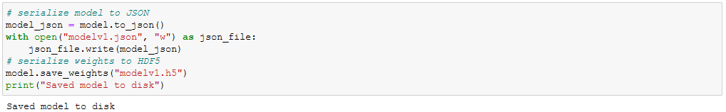

Testing our model on test data.

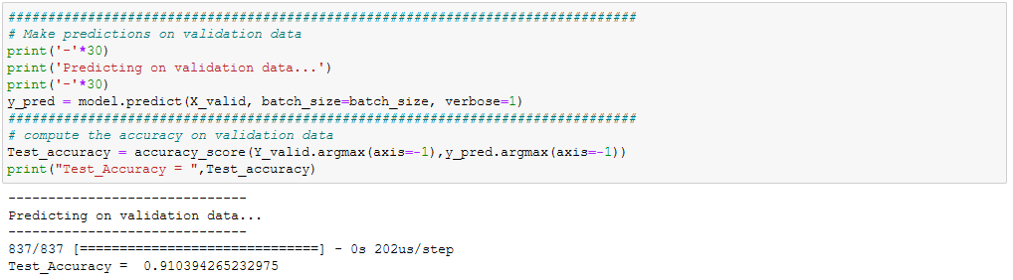

And now plotting the confusion matrix.

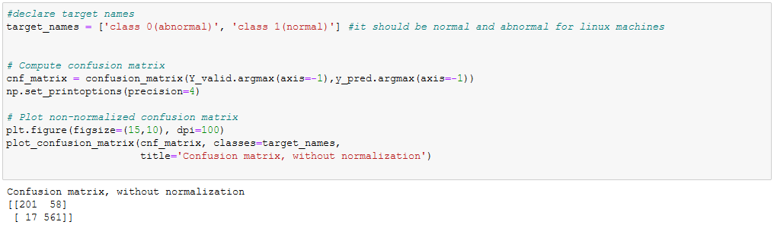

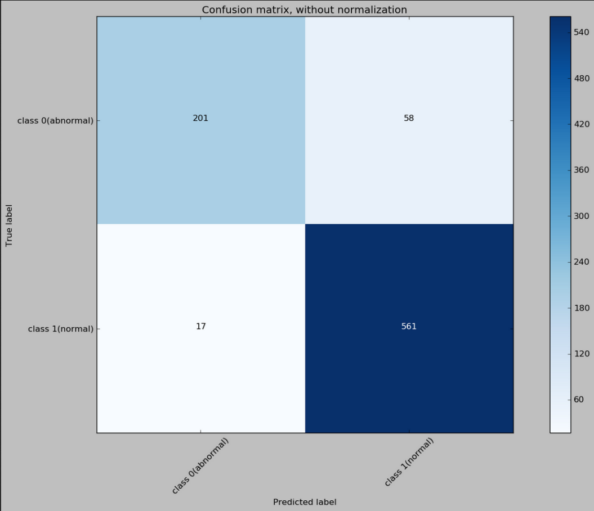

Now we create a script to take input and perform prediction on it.

First we load the model from the disk.

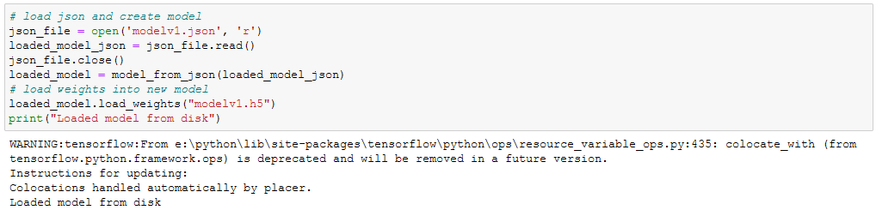

Next we take in custom input.

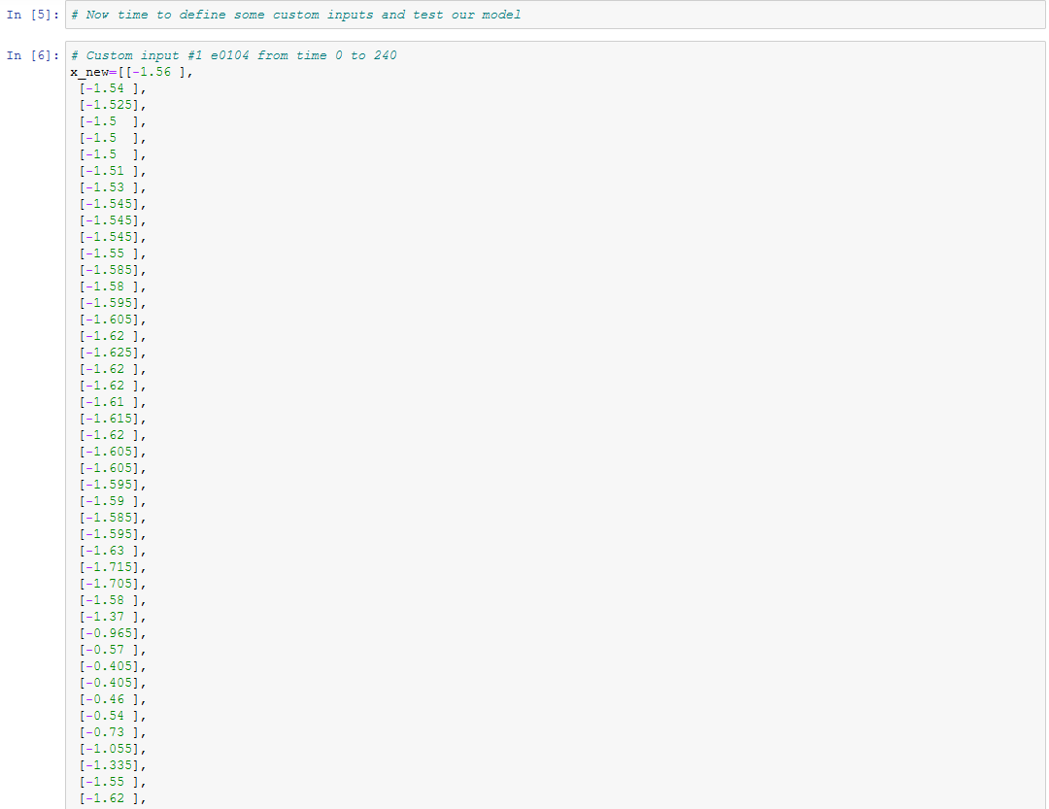

We take in 240 values.

Plot the input just to show the user the ECG.

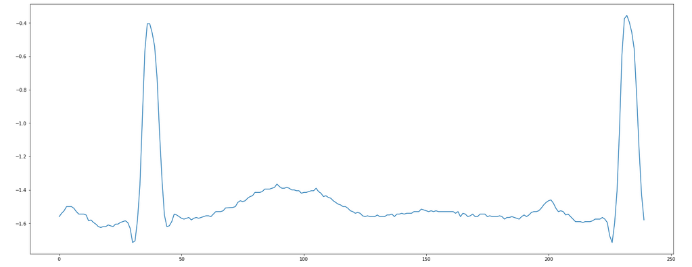

Then we perform the prediction. In this example we do it on a known ECG wave.

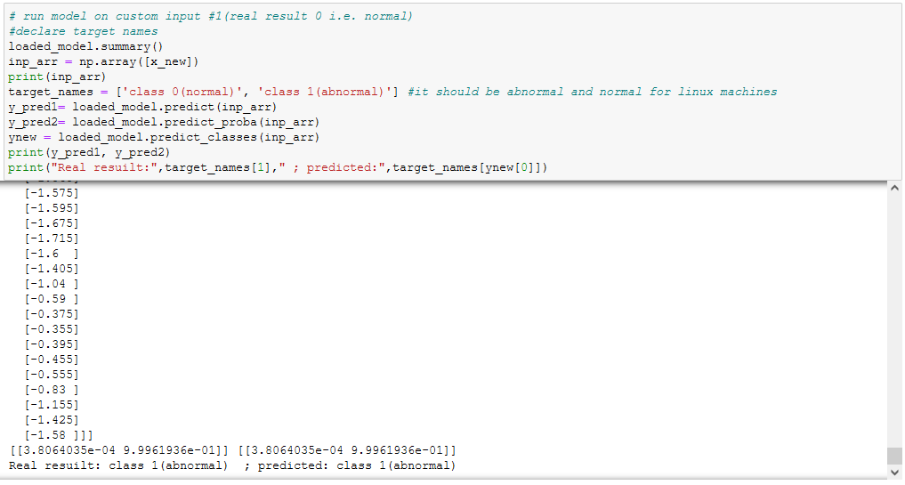

We also check the angle made by the R peak in the wave and plot it.

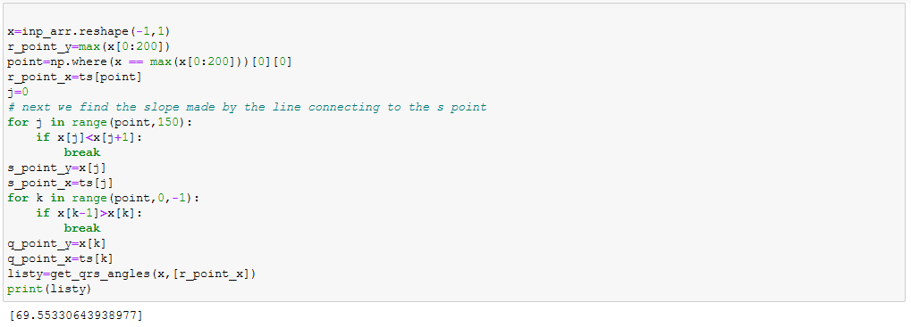

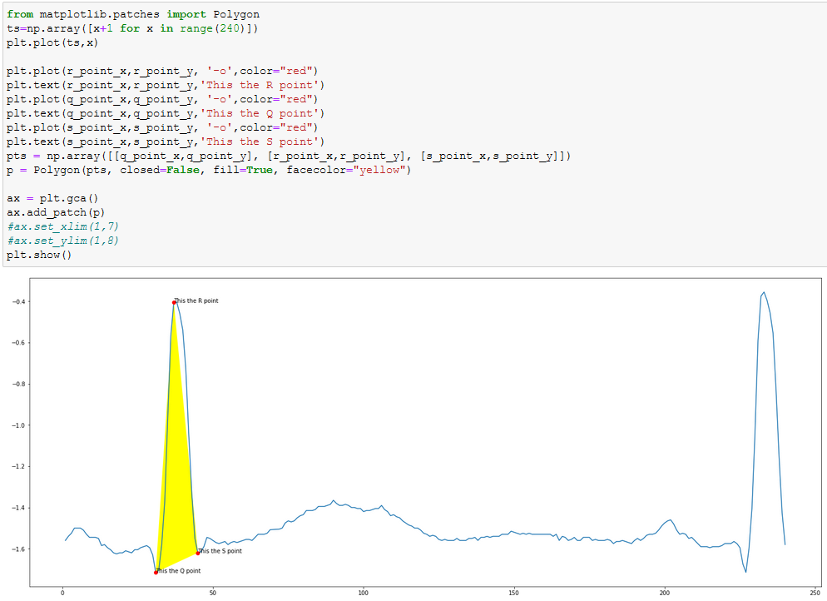

**Future application**

* The current model only predicts whether a patient is suffering from myocardial ischemia or not. By feeding more data records of patients suffering from different cardiac disease like myocardial infarction, bradycardia, tachycardia. This model will also be able to predict whether a patient is suffering from the mentioned disease or not.
* A portable device can be made which will take the ECG signals as input and will predict whether a person is suffering from cardiac disease or not.

**Bibliography**

* 1. https://litfl.com/myocardial-ischaemia-ecg-library/
  2. https://physionet.org/content/edb/1.0.0/
  3. <https://www.cnr.it/en>
  4. Hin Wai lui, King Lau Chow , “Multiclass classification of myocardial infarction with convolutional and recurrent neural networks for portable ECG devices” available online at https://www.sciencedirect.com/science/article/pii/S2352914818301333